**Setting email on outlook**

1. Start program Microsoft Outlook / Or go to control panel > Mail (Microsoft Outlook 2013)

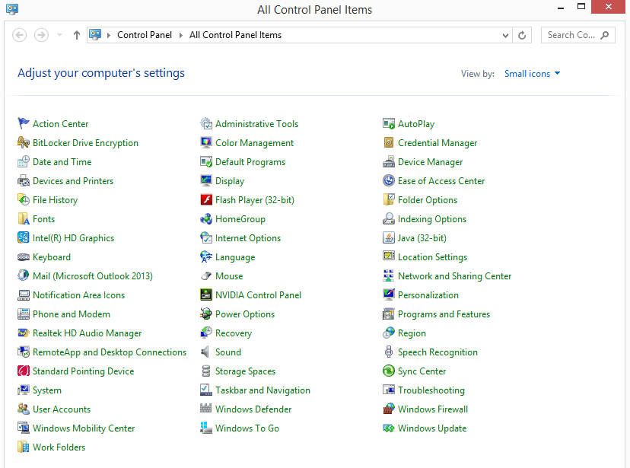

1. Go to email account

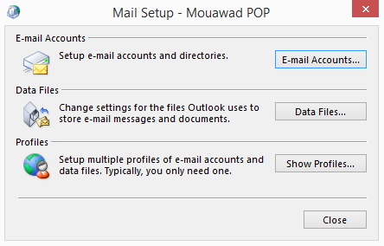

1. E-mail > New… > Email Account > Next

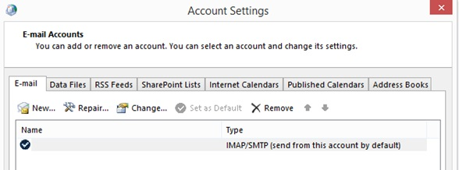

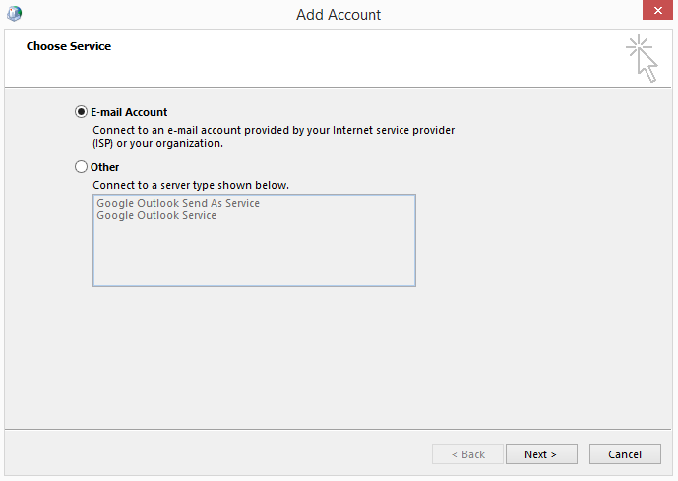

1. Add Account > Check “Manual setup or additional server types” > Click “Next”

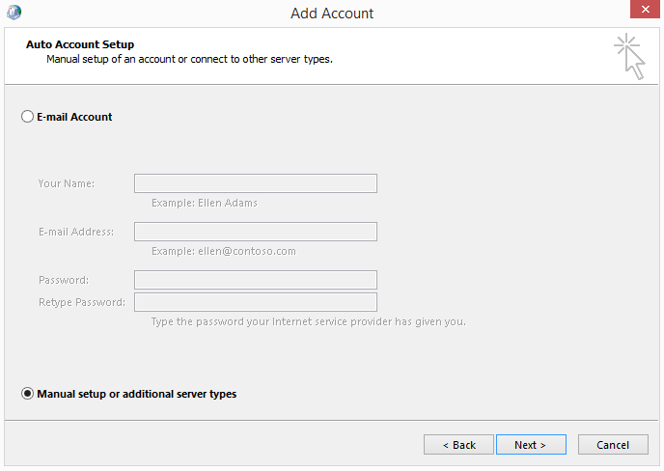

1. Select “Connect to a POP or IMAP email account” > Next

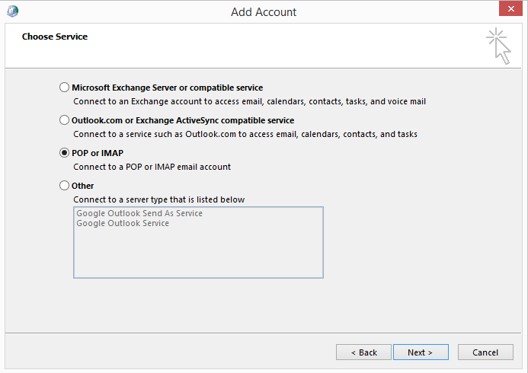

1. Fill detail:
   1. Your Name “Fill your name and last name”
   2. Email address
   3. Account Type = IMAP
   4. Incomming mail server = imap.gmail.com
   5. Outgoing mail server (SMTP) = smtp.gmail.com
   6. User Name = Email address
   7. Password = Your email password
2. Click “More Settings …”

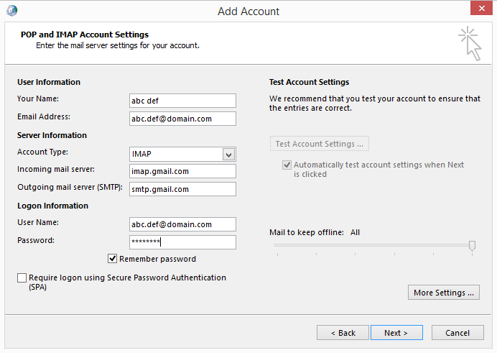

1. Select tab “Outgoing Server” > Check on “My outgoing server (SMTP) requires authentication”

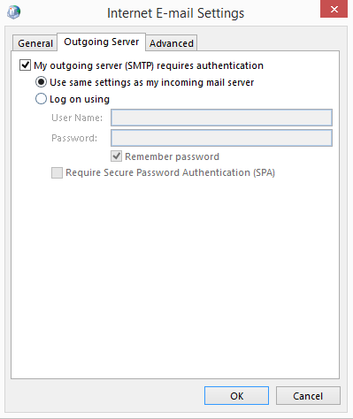 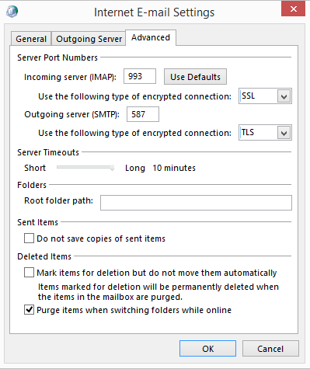

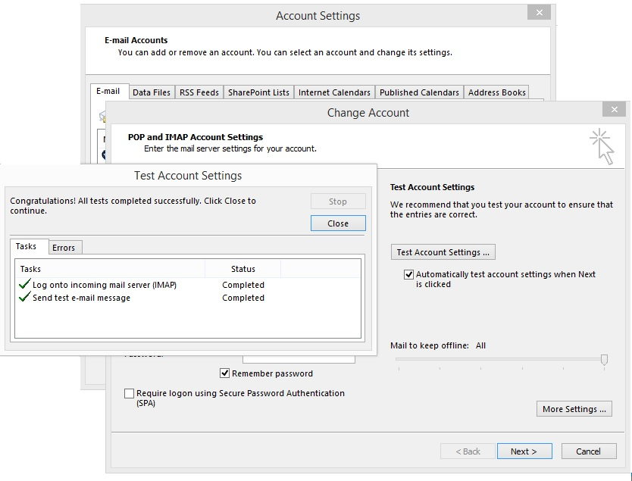

1. Finish > All Done.

